

Application Form

Pilot Action B

Rehab Product Validation Service - CUAS

Version 1.1

11 2024

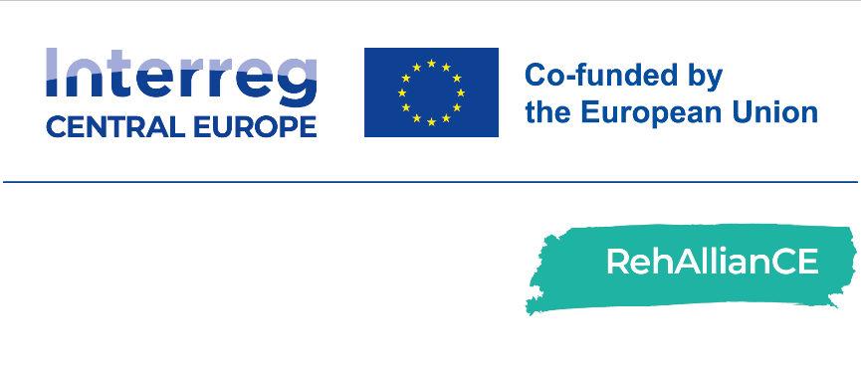

Application Form

|  |  |
| --- | --- |
| FH Kärnten | Rehab Product Validation Service |
| This application form must be completed and sent to email address [rehalliance-submission@bioregio-stern.de](mailto:rehalliance-submission@bioregio-stern.de) between:   * + November 25th, 2024 and February 14th, 2025.   Please complete the application form as exhaustively and accurately as possible.  For questions related to completing this form, please contact: Dr. Johannes Oberzaucher, email address: [j.oberzaucher@fh-kaernten.at](mailto:j.oberzaucher@fh-kaernten.at) | |

|  |  |
| --- | --- |
| Submitted by (Name): | Name & Surname (this is the person who will receive all the official communications about the programme):  Title:  E-Mail:  Telephone Number:  Co-applicant(s) (if applicable): |
| Organisation and Address: | Name of Organisation:  Name of the Legal Representative:  Department:  Address:  Country: |

|  |  |
| --- | --- |
| Personal data processing | RehAllianCe is an Interreg CE project, which will support European SMEs in the area of Rehabilitation. The aim of this project is to strengthen the innovation capacities in central Europe to accelerate the development of products, services or solution for the rehabilitation of patients. To this end the RehAllianCE partner foster cooperation for a smart Europe by providing support along the whole value chain for SMEs in central European countries and in other European countries.  All information will be treated with the utmost confidentiality. The RehAllianCE consortium partners will ensure the confidentiality of all information and data received from applicants throughout the application and selection process. Any such information will be shared only with relevant internal personnel for the purpose of evaluating the data. Please check the consent box below according to your preferences.  I confirm that the company named above meets the [SME definition of the EU Commission](https://single-market-economy.ec.europa.eu/smes/sme-fundamentals/sme-definition_en).  I confirm that the company named above is located in the Interreg CE programme area  I have the right to give out information regarding this/these rehab product(s), solution(s) or service(s).  I am authorized to submit this application on behalf of my institution/company.  I hereby consent to the completeness and accuracy of information given in this application as well as all documents.  I approve the storage and processing of transmitted personal information and data in accordance with the [EU General Data Protection Regulation](https://eur-lex.europa.eu/legal-content/EN/TXT/?uri=CELEX%3A02016R0679-20160504&qid=1532348683434).  I consent to the use of my personal data for the purpose of processing my application. I understand that this data will be shared within the RehAllianCE consortium and that it will not be passed on to third parties.  I agree to provide the RehAllianCE partner with an evaluation on the service within one month after the end of the Pilot Action (The recipient will use and fill in a dedicated reporting template provided by the RehAllianCE partner). |
| Name of the legal representative, date and signature |  |

Project Details

|  |  |
| --- | --- |
| Project title | *Insert the title of your project* |
| Management team and their expertise | *Provide the list of project partners and their expertise*  First Name:  Last Name:  Expertise:  *(Extend list if needed)* |
| Project summary | *Provide brief summary of the project (about 500 characters per item)*   1. *About your rehab product, solution or service*   about 500 characters)   1. *Technology*   (about 500 characters)   1. *Maturity Level (for Technology Readiness Level (TRL) see list below)*   (about 500 characters)   1. *Impact for Rehabilitation and healthcare sector*   (about 500 characters)   1. *Unmet medical need*   (about 500 characters) |
| Technology Type: | *Select Technology Type from list*  **Health:** Orthopedy, mental, stroke.  **Robotic:** Exoskeleton, wearable.  **ICT:** Telemedicine, health app.  **Other.** Please describe: |
| Maturity Level (TRL 5 or Higher) | *Select Technology Readiness Level (TRL) from list*  **☐ TRL 1** – basic principles observed and reported  **☐ TRL 2** – technology concept and application formulated  **☐ TRL 3** – analytical and experimental proof of concept  **☐ TRL 4** – technology demonstration and robustness analysis  **☐ TRL 5** – method validation with clinical samples  **☐ TRL 6** – model validation in large clinical trial  **☐ TRL 7** – final prototype product design and testing  **☐ TRL 8** – demonstrate clinical-economic benefits  **☐ TRL 9** – incorporation in hospital workflow |
| Commitment to Active Participation | *By ticking the boxes below the applicant agrees to the active engagement in the pilot action.*  **☐ Time and Resource Allocation:** The SME must dedicate the necessary time and resources to participate in pilot activities, including meetings, testing sessions, and evaluations.  **☐ Prototype or Product Transfer:** SMEs must be prepared to provide their product or prototype for testing at designated facilities, ensuring that the technology is available for comprehensive evaluation. **Note: CUAS does not cover transport costs in cases where transport of products or prototypes is required.**  **☐ Collaboration and Feedback:** A willingness to collaborate with RehAllianCE partners and provide detailed feedback throughout the process, enabling continuous refinement of both the product and services.  **☐ Travel Availability:** Where applicable, SMEs may need to travel to testing sites. Flexibility and availability to travel will be considered in the selection process. **Note: CUAS does not cover travel expenses in cases where travel of personnel is required.** |
| Innovation and Impact:  Relevance to the rehabilitation | *Please, describe in more detail the relevance, innovation and potential impact of your product, service, technology, solution for rehabilitation. Also provide information on costs and marketing potential.*  (about 500 – 1000 characters) |
| Social impact:  Potential to Improve Quality of Life | *Please, describe how your assistive technology will improve users’ quality of life, functional abilities, or overall well-being of individuals undergoing rehabilitation over existing approaches.*  (about 500 – 1000 characters) |
| User-centric approach, product safety and ethical issues | *Please explain how your product, service or solution meets the needs and preferences of end users, considering the following aspects.*   1. *Testing with End Users: addressing needs, preferences, and feedback of individuals undergoing rehabilitation in the design and development process.*   (about 500 – 1000 characters)   1. *Ease of Use: demonstrate that your product, service or solution poses no harm to users and adheres to ethical guidelines and regulations.*   (about 500 – 1000 characters) |
| Scientific validity | *Describe how services or solutions is based on scientific principles, evidence-based practices, or validated theories.*  (about 500 – 1000 characters) |

Validation Services

|  |  |
| --- | --- |
| Select individual modules or complete validation service | *SMEs do not pay for the services as the project partners provide staff and expertise.*  **Applicants can combine different modules. The services provided cannot exceed €22,000 (according to chapter I.4.4.3 of the** [**Programme Manual Interreg CENTRAL EUROPE 2021-2027**](https://www.interreg-central.eu/wp-content/uploads/2024/04/Interreg-CE-Programme_Manual_v4.pdf) **for indirect State aid (SA) granted under GBER Article 20a to an undertaking that is the final beneficiary of project activities).**  The prices of the modules have an average value of approx. € 7.333,33, except the module B.2.1, which has an average value of approx. € 14.666,67.  **☐ Service B.1:** Living Lab pre-acceptance evaluation service: total value up to € 22,000  **☐ Module B.1.1 -** User Experience Analysis  **☐ Module B.1.2 -** Acceptance and Usage Analysis  **☐ Module B.1.3 -** Ethical Usage Analysis  **☐ Service B.2:** User-centred validation service: total value up to € 22,000  **☐ Module B.2.1 -** Motion Analysis  **☐ Module B.2.2 -** Ethical Usage Analysis  **☐ Service B.3:** Rehabilitation Use-Case validation service: total value up to € 22,000  **☐ Module B.3.1 -** User Experience Analysis  **☐ Module B.3.2 -** Domain Specific Focus Group  **☐ Module B.3.3** - Transnational rehabilitation process analysis  *○ Transnational rehabilitation process analysis: 7000€* |
| Service on Technology/Target Group/Expertise Required | *Provide details of your request, what kind of support you need to implement advanced technologies in your product, service or solution.*  (about 1000 – 1500 characters) |