

Application Form

Pilot Action A

Rehab Product Validation Service - PBN

Version 1.1

11 2024

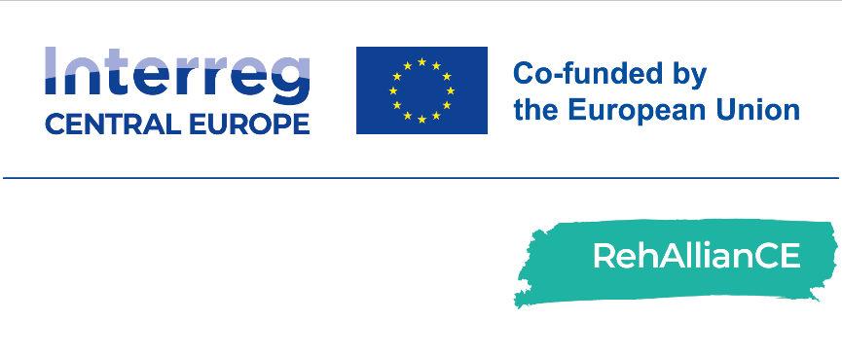

Application Form

|  |  |
| --- | --- |
| PBN - Advanced Management | Rehab Product Validation Service |
| This application form must be completed and sent to email address [rehalliance-submission@bioregio-stern.de](mailto:rehalliance-submission@bioregio-stern.de) between:   * + November 25th, 2024 and February 14th, 2025.   Please complete the application form as exhaustively and accurately as possible.  For questions related to completing this form, please contact: Krisztina Bardos, email address: [digital@pbn.hu](mailto:digital@pbn.hu) | |

|  |  |
| --- | --- |
| Submitted by (Name): | Name & Surname (this is the person who will receive all the official communications about the programme):  Title:  E-Mail:  Telephone Number:  Co-applicant(s) (if applicable): |
| Organisation and Address: | Name of Organisation:  Name of the Legal Representative:  Department:  Address:  Country: |

|  |  |
| --- | --- |
| Personal data processing | RehAllianCe is an Interreg CE project, which will support European SMEs in the area of Rehabilitation. The aim of this project is to strengthen the innovation capacities in central Europe to accelerate the development of products, services or solution for the rehabilitation of patients. To this end the RehAllianCE partner foster cooperation for a smart Europe by providing support along the whole value chain for SMEs in Central European countries and in other European countries.  All information will be treated with the utmost confidentiality. The RehAllianCE consortium partners will ensure the confidentiality of all information and data received from applicants throughout the application and selection process. Any such information will be shared only with relevant internal personnel for the purpose of evaluating the data. Please check the consent box below according to your preferences.  I confirm that the company named above meets the [SME definition of the EU Commission](https://single-market-economy.ec.europa.eu/smes/sme-fundamentals/sme-definition_en).  I confirm that the company named above is located in the Interreg CE programme area  I have the right to give out information regarding this/these rehab product(s), solution(s) or service(s).  I am authorized to submit this application on behalf of my institution/company.  I hereby consent to the completeness and accuracy of information given in this application as well as all documents.  I approve the storage and processing of transmitted personal information and data in accordance with the [EU General Data Protection Regulation](https://eur-lex.europa.eu/legal-content/EN/TXT/?uri=CELEX%3A02016R0679-20160504&qid=1532348683434).  I consent to the use of my personal data for the purpose of processing my application. I understand that this data will be shared within the RehAllianCE consortium and that it will not be passed on to third parties.  I agree to provide the RehAllianCE partner with an evaluation on the service within one month after the end of the Pilot Action (The recipient will use and fill in a dedicated reporting template provided by the RehAllianCE partner). |
| Name of the legal representative, date and signature |  |

Project Details

|  |  |
| --- | --- |
| Project title | *Insert the title of your project* |
| Management team and their expertise | *Provide the list of project partners and their expertise*  First Name:  Last Name:  Expertise:  *(Extend list if needed)* |
| Project summary | *Provide brief summary of the project (about 500 characters per item)*   1. *About your rehab product, solution or service*   (about 500 characters)   1. *Technology*   (about 500 characters)   1. *Maturity Level (for Technology Readiness Level (TRL) see list below)*   (about 500 characters)   1. *Impact for Rehabilitation and healthcare sector*   (about 500 characters)   1. *Unmet medical need*   (about 500 characters) |
| Technology Type: Assistive Technology for activities of daily living (ADLs) | *Select Technology Type from list*  **Mobility Aids:** Wheelchairs, walkers, powered scooters.  **Visual Aids:** Screen readers, magnifiers, tactile devices.  **Hearing Aids:** Devices for sound amplification and support.  **Voice and Communication Aids:** Speech-generating devices, text-to-speech software.  **Daily Living Aids:** Tools that assist with self-care tasks such as dressing, eating, and grooming.  **Cognitive Devices:** Technologies to assist with memory, attention, and cognitive functions.  **Other.** Please describe: |
| Maturity Level (TRL 5 or Higher) | *Select Maturity Level from list*  **☐ TRL 1** – basic principles observed and reported  **☐ TRL 2** – technology concept and application formulated  **☐ TRL 3** – analytical and experimental proof of concept  **☐ TRL 4** – technology demonstration and robustness analysis  **☐ TRL 5** – method validation with clinical samples  **☐ TRL 6** – model validation in large clinical trial  **☐ TRL 7** – final prototype product design and testing  **☐ TRL 8** – demonstrate clinical-economic benefits  **☐ TRL 9** – incorporation in hospital workflow |
| Commitment to Active Participation | *By ticking the boxes below the applicant agrees to the active engagement in the pilot action.*  **☐ Time and Resource Allocation:** The SME must dedicate the necessary time and resources to participate in pilot activities, including meetings, testing sessions, and evaluations.  **☐ Prototype or Product Transfer:** SMEs must be prepared to provide their product or prototype for testing at **designated** facilities, ensuring that the technology is available for comprehensive evaluation. **Note: PBN does not cover transport costs in cases where transport of products or prototypes is required.**  **☐ Collaboration and Feedback:** A willingness to collaborate with RehAllianCE partners and provide detailed feedback throughout the process, enabling continuous refinement of both the product and services.  **☐ Travel Availability:** Where applicable, SMEs may need to travel to testing sites. Flexibility and availability to travel will be considered in the selection process. **Note: PBN does not cover travel expenses in cases where travel of personnel is required.** |
| Innovation and Impact on ADLs: | *Please describe how your product, service or solution will address the following challenges:*   1. *Enhance Independence: Allow users to perform daily tasks with greater autonomy, reducing the need for external assistance.*   (about 500 - 1000 characters)   1. *Address Unmet Needs: Provide new or significantly improved solutions for challenges that current assistive technologies do not adequately address.*   (about 500 - 1000 characters)   1. *Market Potential: Show clear potential for widespread adoption, scalability, and commercial success.*   (about 500 - 1000 characters) |
| User-Centred Design and Usability: | *Please explain how your product, service or solution meets the needs and preferences of end users, considering the following aspects.*   1. *Testing with End Users: Technologies that have already been tested with real users and have incorporated feedback will be given additional consideration.*   (about 500 - 1000 characters)   1. *Ease of Use: Products must be user-friendly, with a design that takes into account the limitations of the target audience, whether physical, sensory, or cognitive.*   (about 500 - 1000 characters) |
| Ethical Standards, Safety, and Regulatory Compliance: | *Please explain how your product, service or solution meets the following aspects.*   1. *Regulatory Compliance: Products must comply with relevant healthcare regulations, such as medical device standards, and meet all necessary safety requirements.*   (about 500 characters)   1. *User Privacy and Data Protection: Technologies that collect user data (e.g., wearables, or monitoring devices) must have strong data protection and privacy measures in place, in compliance with regulations like the GDPR.*   (about 500 characters) |
| Social impact:  Potential to Improve Quality of Life: | *Please, describe how your assistive technology will improve users’ quality of life.*  (about 500 characters) |

Validation Services

|  |  |
| --- | --- |
| Select complete validation service(s) | *SMEs do not pay for the services as the project partners provide staff and expertise.*  **Applicants must select a full-service package. The services provided cannot exceed €22,000 (according to chapter I.4.4.3 of the** [**Programme Manual Interreg CENTRAL EUROPE 2021-2027**](https://www.interreg-central.eu/wp-content/uploads/2024/04/Interreg-CE-Programme_Manual_v4.pdf) **for indirect State aid (SA) granted under GBER Article 20a to an undertaking that is the final beneficiary of project activities).**  **☐ Service A:** Validation Service: total value up to € 22,000  **Service A.1**: Product Validation of Different Maturity Levels Before Market Access with real test environment  **Service A.2:** Emotional Analysis – qualitative analysis (descriptive)  **Module A.2.1** – Facial Recognition Emotional Analysis  **Module A.2.2 –** EEG Headset Emotional Analysis  **Module A.2.3 -** Emotional Analysis – Respiratory Emotional Analysis: € 3,000  **Service A.3:** Analysis of User Feedback & Improvement of UX (Quantitative Analysis) |
| Service on Technology/Target Group/Expertise Required | *Provide details of your request, what kind of support you need to implement advanced technologies in your product, service or solution.*  (about 1000 -1500 characters) |