

Application Form

Pilot Action C

Consulting Service - NSB

Version 1.2

03 2025

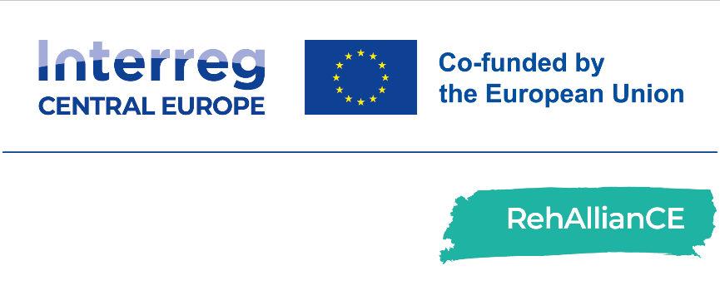

Application Form

|  |  |
| --- | --- |
|  | Consulting Service |
| This application form must be completed and sent to email address [rehalliance-submission@bioregio-stern.de](mailto:rehalliance-submission@bioregio-stern.de) between:   * + March 3rd, 2025 and March 16th, 2025.   Please complete the application form as exhaustively and accurately as possible.  For questions related to completing this form, please contact: Sara Canella, email address: [s.canella@nsbproject.com](mailto:s.canella@nsbproject.com) | |

|  |  |
| --- | --- |
| Submitted by (Name): | Name & Surname (this is the person who will receive all the official communications about the programme):  Title:  E-Mail:  Telephone Number:  Co-applicant(s) (if applicable): |
| Organisation and Address: | Name of Organisation:  Name of the Legal Representative:  Department:  Address:  Country: |

|  |  |
| --- | --- |
| Personal data processing | RehAllianCe is an Interreg CE project, which will support European SMEs in the area of Rehabilitation. The aim of this project is to strengthen the innovation capacities in central Europe to accelerate the development of products, services or solution for the rehabilitation of patients. To this end the RehAllianCE partner foster cooperation for a smart Europe by providing support along the whole value chain for SMEs in central European countries and in other European countries.  All information will be treated with the utmost confidentiality. The RehAllianCE consortium partners will ensure the confidentiality of all information and data received from applicants throughout the application and selection process. Any such information will be shared only with relevant internal personnel for the purpose of evaluating the data Please check the consent box below according to your preferences.  I confirm that the company named above meets the [SME definition of the EU Commission](https://single-market-economy.ec.europa.eu/smes/sme-fundamentals/sme-definition_en).  I confirm that the company named above is located in the Interreg CE programme area  I have the right to give out information regarding this/these rehab product(s), solution(s) or service(s)  I am authorized to submit this application on behalf of my institution/company  I hereby consent to the completeness and accuracy of information given in this application as well as all documents  I approve the storage and processing of transmitted personal information and data in accordance with the [EU General Data Protection Regulation](https://eur-lex.europa.eu/legal-content/EN/TXT/?uri=CELEX%3A02016R0679-20160504&qid=1532348683434).  I consent to the use of my personal data for the purpose of processing my application. I understand that this data will be shared within the RehAllianCE consortium and that it will not be passed on to third parties.  I agree to provide the RehAllianCE partner with an evaluation on the service within one month after the end of the Pilot Action (The recipient will use and fill in a dedicated reporting template provided by the RehAllianCE partner). |
| Name of the legal representative, date and signature |  |

Project Details

|  |  |
| --- | --- |
| Project title | *Insert the title of your project* |
| Management team and their expertise | *Provide the list of project partners and their expertise*  First Name:  Last Name:  Expertise:  *(Extend list if needed)* |
| Project summary | *Provide brief summary of the project (about 500 characters per item)*   1. *About your rehab product, solution or service*   about 500 characters)   1. *Technology*   (about 500 characters)   1. *Maturity Level (for Technology Readiness Level (TRL), Manufacturing Readiness Level (MRL), and Integration Readiness Level (IRL) see lists below)*   (about 500 characters)   1. *Impact for Rehabilitation and healthcare sector*   (about 500 characters)   1. *Unmet medical need*   (about 500 characters) |
| Technology Type: | *Select Technology Type from list*  **Rehab robots/exoskeletons**.  **Assistive devices**.  **Health apps**.  **Telemetric tools**.  **Wearables**.  **Other.** Please describe: |
| Maturity Level (TRL 8 or Higher) | *Select Technology Readiness Level (TRL) from list*  **☐ TRL 1** – basic principles observed and reported  **☐ TRL 2** – technology concept and application formulated  **☐ TRL 3** – analytical and experimental proof of concept  **☐ TRL 4** – technology demonstration and robustness analysis (in Lab)  **☐ TRL 5** – method validation with clinical samples  **☐ TRL 6** – model validation in large clinical trial  **☐ TRL 7** – final prototype product design and testing  **☐ TRL 8** – complete product demonstrates clinical-economic benefits  **☐ TRL 9** – product proven in hospital workflow |
| Manufacturing Readiness Level (MRL 6 or Higher) | *Select Manufacturing Readiness Level (MRL) from list*  **☐ MRL 1** – Basic Manufacturing Implications Assessed  **☐ MRL 2** - Manufacturing Concepts Defined  **☐ MRL 3 -** Manufacturing Concepts Developed  **☐ MRL 4** - Laboratory Manufacturing Process Demonstration  **☐ MRL 5** - Manufacturing Process Development (produce components in a production relevant environment)  **☐ MRL 6** - Critical Manufacturing Process Prototyped (produce a prototype system in a production relevant environment)  **☐ MRL 7** - Prototype Manufacturing System (produce systems, subsystems or components in a production relevant environment)  **☐ MRL 8** - Manufacturing Process Maturity Demonstration (ready to begin low-rate production)  **☐ MRL 9** - Manufacturing Processes Proven (ready to produce full-rate production)  **☐ MRL 10** - Full Rate Production demonstrated and lean production practices in place |
| Integration Readiness Level (IRL 8 or Higher) | *Select Integration Readiness Level (IRL) from list*  **☐ IRL 1** - An interface between technologies has been identified with sufficient detail to allow characterization of the relationship  **☐ IRL 2** - There is some level of specificity to characterize the interaction between technologies through their interface  **☐ IRL 3** - There is compatibility between technologies to orderly and efficiently integrate and interact  **☐ IRL 4** - There is sufficient detail in the quality and assurance of the integration between technologies  **☐ IRL 5** - There is sufficient control between technologies necessary to establish, manage, and terminate the integration  **☐ IRL 6** - The integrating technologies can accept, translate, and structure information for its intended application  **☐ IRL 7** - The integration of technologies has been verified and validated with sufficient detail to be actionable  **☐ IRL 8** - Actual integration completed and Mission Qualified through test and demonstration, in the system environment  **☐ IRL 9** - Integration is Mission Proven through successful mission operations |
| Commitment to Active Participation | *By ticking the boxes below the applicant agrees to the active engagement in the pilot action.*  **☐ Time and Resource Allocation:** The SME must dedicate the necessary time and resources to participate in pilot activities, including meetings, testing sessions, and evaluations.  **☐ Collaboration and Feedback:** A willingness to collaborate with RehAllianCE partners and provide detailed feedback throughout the process, enabling continuous refinement of both the product and services. |
| Clinical feasibility: | *Please, describe at least one recent positive reference in the rehabilitation domain.*  (about 500 - 1000 characters) |
| Social impact:  Potential to Improve Quality of Life | *Please, describe how your assistive technology will improve users’ quality of life, functional abilities, or overall well-being of individuals undergoing rehabilitation over existing approaches.*  (about 500 - 1000 characters) |
| Match with the technology-rehabilitation areas’ needs based on the NSB framework | *Describe in which areas of healthcare (e.g., orthopaedics, neurology, cardiology, etc.) your technology will be applied to be effective for rehabilitation and which market needs it matches.*  (about 500 - 1000 characters) |

Consulting Service

|  |  |
| --- | --- |
| Select complete consulting service | *SMEs do not pay for the services as the project partners provide staff and expertise.*  **Applicants must select a full-service package. The services provided cannot exceed €22,000 (according to chapter I.4.4.3 of the** [**Programme Manual Interreg CENTRAL EUROPE 2021-2027**](https://www.interreg-central.eu/wp-content/uploads/2024/04/Interreg-CE-Programme_Manual_v4.pdf) **for indirect State aid (SA) granted under GBER Article 20a to an undertaking that is the final beneficiary of project activities).**  **☐ Service C:** Consulting Service: total value up to € 22,000  **Module C.1** - Market & regulatory assessment  **Module C.2** - Competitive landscape analysis  **Module C.3** - Tech & Industry partnership analysis  *○ Transnational rehabilitation process analysis: 7000€* |
| Service on Technology/Target Group/Expertise Required | *Provide details of your request, what kind of support you need to implement advanced technologies in your product, service or solution.*  (about 1000 - 1500 characters) |